SIMATS ENGINEERING
ASSESSMENT TOOL 1
COURSE NAME: Artificial Intelligence COURSE CODE: CSA17
COURSE OUTCOME COVERED
CO3: Analyze knowledge representation and reasoning using propositional logic, FOL, inference, resolution, chaining methods, knowledge representation to perform logical reasoning for drawing valid conclusions and decision making. (BL4)
Assessment Tool Weightage: 20% Duration: 1 Hour
Questions: 5 Total Marks: 30
Annexure A
ANALYTICAL PROBLEM SOLVING
Code of Conduct:
I R. Deekshitha (192412194) certify that this submission is my original work and that I have adhered to the guidelines specified for this assessment.
I understand that any violation of academic integrity rules will result in disciplinary action.
Signature of the student: R. Deekshitha
Q1. English → Propositional Logic → CNF
Problem understanding and method
Each sentence is translated using symbols, then converted to CNF with the standard 5-step procedure: (1) write symbols, (2) form the logical sentence, (3) eliminate implications (P → Q ≡ ¬P ∨ Q), (4) move ¬ inward using De Morgan's laws, (5) distribute ∨ over ∧ and write the clauses.
(i) “If it rains, the ground gets wet. If the ground is wet, the match is cancelled.”
Step | Work
1. Symbols | R = It rains; W = The ground is wet; C = The match is cancelled
2. Logical sentences | S1: R → W S2: W → C Query: R → C?
3. Eliminate implications | S1: ¬R ∨ W S2: ¬W ∨ C
4. Move ¬ inward | No negation applies to a compound expression, so no change
5. Distribute ∨ over ∧ | No ∧ present, so no change
CNF clauses | {¬R, W} and {¬W, C}

Derivation (Modus Ponens chain): assume R is true. (1) R and R → W give W. (2) W and W → C give C.
Cross-check by resolution: resolving {¬R, W} with {¬W, C} on W gives {¬R, C} ≡ R → C. This is hypothetical syllogism.
Interpretation: Yes, the match is cancelled when it rains. The conclusion is valid because both rules chain through the shared proposition W.
(ii) “It is not the case that both the alarm is on and the door is locked.”
Step | Work
1. Symbols | A = The alarm is on; D = The door is locked
2. Logical sentence | ¬(A ∧ D)
3. Eliminate implications | None present
4. Move ¬ inward (De Morgan) | ¬(A ∧ D) ≡ ¬A ∨ ¬D
5. Distribute ∨ over ∧ | Already a single clause
CNF clause | { ¬A, ¬D }

Interpretation: at least one of the two is false. The only forbidden situation is A = T and D = T together.
(iii) “Either the power fails or the backup generator works, but not both.”
Step | Work
1. Symbols | P = The power fails; G = The backup generator works
2. Logical sentence | Exclusive OR: (P ∨ G) ∧ ¬(P ∧ G) [equivalently P ↔ ¬G]
3. Eliminate implications | Using the biconditional form: (P → ¬G) ∧ (¬G → P) ≡ (¬P ∨ ¬G) ∧ (G ∨ P)
4. Move ¬ inward (De Morgan) | ¬(P ∧ G) ≡ ¬P ∨ ¬G
5. Distribute ∨ over ∧ | Already a conjunction of clauses
CNF clauses | { P, G } and { ¬P, ¬G }

Check: P = G = T violates { ¬P, ¬G }; P = G = F violates { P, G }. Only (T, F) and (F, T) satisfy both clauses, which is exactly “exactly one”.
Sentence | CNF | Clauses
(i) | (¬R ∨ W) ∧ (¬W ∨ C) | 2
(ii) | ¬A ∨ ¬D | 1
(iii) | (P ∨ G) ∧ (¬P ∨ ¬G) | 2
Q2. Resolution Refutation: Prove C
Problem understanding and method
KB = { ¬A ∨ B, ¬B ∨ C, A }, Goal = C. Resolution refutation is chosen because the KB is already in clause form and the method is sound and complete for propositional logic: KB ⊨ C exactly when KB ∪ { ¬C } is unsatisfiable (□ is derived).
Step 1 – Clause form of the KB
No. | Clause | Source
1 | ¬A ∨ B | KB (A → B)
2 | ¬B ∨ C | KB (B → C)
3 | A | KB fact

Step 2 – Negate the goal
¬C is added as clause 4.
Step 3 – Apply resolution iteratively
Step | Clauses resolved | Resolved on | Resolvent
1 | (4) ¬C and (2) ¬B ∨ C | C | (5) ¬B
2 | (5) ¬B and (1) ¬A ∨ B | B | (6) ¬A
3 | (6) ¬A and (3) A | A | (7) □

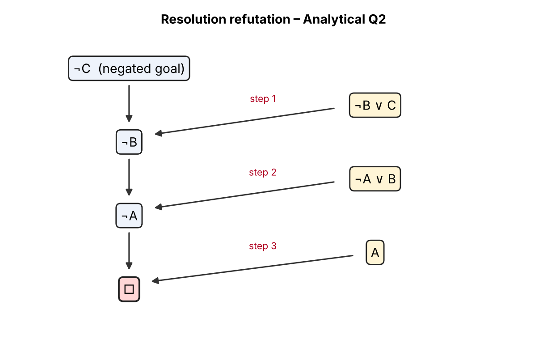

The empty clause □ is derived, so KB ∪ { ¬C } is unsatisfiable. Therefore KB ⊨ C is proved. This agrees with the direct Modus Ponens chain: A ⇒ B ⇒ C.
Q3. First-Order Logic Translation and Unification
(i) “Every student who studies AI will pass the examination.”
Predicates: Student(x), Studies(x, AI), Passes(x, Exam). A universal statement uses ∀ with an implication:
∀x [ Student(x) ∧ Studies(x, AI) → Passes(x, Exam) ]
The connective inside ∀ must be → (not ∧). With ∧ the sentence would claim that everything is a student who studies AI.
(ii) “There exists at least one professor who teaches every subject.”
Predicates: Professor(x), Subject(y), Teaches(x, y). The existential quantifier comes first and contains the universal one:
∃x [ Professor(x) ∧ ∀y ( Subject(y) → Teaches(x, y) ) ]
Caution on quantifier order: ∀y ∃x (Subject(y) → Professor(x) ∧ Teaches(x, y)) is weaker. It only says that every subject has some professor. The required meaning is one professor for all subjects, so ∃ must be outermost.
(iii) Most General Unifier of { P(x, f(y), B), P(A, f(g(z)), B) }
Unification scans both expressions left to right, finds the first disagreement set, binds a variable to the other term (after the occurs check), applies the substitution and repeats. Variables: x, y, z. Constants: A, B.
Step | Expressions after substitution | Disagreement set | Action | θ so far
0 | P(x, f(y), B)  P(A, f(g(z)), B) | { x, A } | x is a variable, A is a constant, no occurs-check issue: bind x/A | { x/A }
1 | P(A, f(y), B)  P(A, f(g(z)), B) | { y, g(z) } | y is a variable, y does not occur in g(z): bind y/g(z) | { x/A, y/g(z) }
2 | P(A, f(g(z)), B)  P(A, f(g(z)), B) | none | The expressions are identical, so stop | { x/A, y/g(z) }

Result: unification succeeds. MGU θ = { x/A, y/g(z) }.
Q4. Forward and Backward Chaining
Problem understanding
Item | Content
R1 | Animal(x) ∧ HasWings(x) → Bird(x)
R2 | Bird(x) ∧ CanFly(x) → FlyingBird(x)
R3 | FlyingBird(x) → Migratory(x)
Facts | Animal(Eagle), HasWings(Eagle), CanFly(Eagle)
Query | Migratory(Eagle)

(a) Forward chaining (data-driven)
Start with the known facts. Fire every rule whose premises are all known, add the conclusion, and repeat until no new fact appears (fixed point).
Round | Rule fired | Substitution | New fact inferred | Known facts afterwards
0 | – | – | – | Animal(E), HasWings(E), CanFly(E)
1 | R1 (R2, R3 not applicable) | {x/Eagle} | Bird(Eagle) | + Bird(E)
2 | R2 | {x/Eagle} | FlyingBird(Eagle) | + FlyingBird(E)
3 | R3 | {x/Eagle} | Migratory(Eagle) | + Migratory(E)
4 | None applicable | – | No new fact | Fixed point reached

Result: 3 rule firings; Migratory(Eagle) is derived. E = Eagle.
(b) Backward chaining (goal-driven): Goal = Migratory(Eagle)
Start from the goal and look for rules whose head unifies with it. The premises become sub-goals (AND), and alternative rules for the same goal would be OR branches.
Level | Goal | How it is reduced | Sub-goals
0 | Migratory(Eagle) | R3 with {x/Eagle}, the only rule with this head | FlyingBird(Eagle)
1 | FlyingBird(Eagle) | R2 with {x/Eagle}, the only rule with this head | Bird(Eagle) AND CanFly(Eagle)
2 | CanFly(Eagle) | Matches a known fact | ✓ proved
2 | Bird(Eagle) | R1 with {x/Eagle}, the only rule with this head | Animal(Eagle) AND HasWings(Eagle)
3 | Animal(Eagle) | Matches a known fact | ✓ proved
3 | HasWings(Eagle) | Matches a known fact | ✓ proved

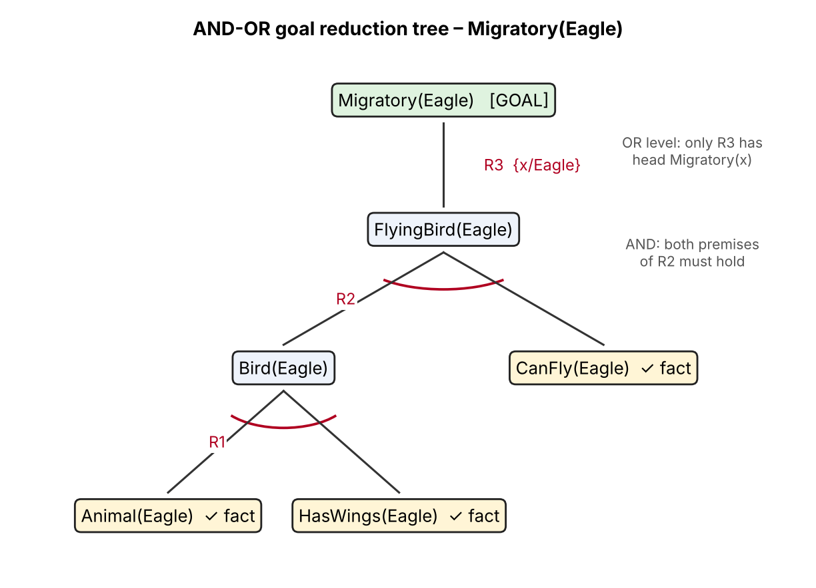
All leaves are facts, so the goal is proved.

(c) Comparison and efficiency (counting inference steps)
Measure | Forward chaining | Backward chaining
Rule applications | 3 (R1, R2, R3) | 3 (R3, R2, R1)
Facts / goals touched | 3 derived facts | 6 goals examined (1 query + 2 intermediate + 3 fact look-ups)
Extra work | 1 closing pass to confirm no new fact | Rule look-up to match each goal head
Irrelevant inference | None: every derived fact is on the path to the goal | None
Total inference steps | 3 firings (+1 closing check) | 3 reductions + 3 fact checks = 6

Verdict: for this KB forward chaining is slightly more efficient. The rules form a single chain, so every derived fact is useful, and no goal-matching overhead is needed. Backward chaining wins when the KB is large and only one specific query is asked, because it never derives facts irrelevant to the goal.
Q5. Truth Table and Resolution Refutation
Formula: F = (P → Q) ∧ (Q → R) ∧ P ∧ ¬R
(a) Truth table
P | Q | R | P → Q | Q → R | P | ¬R | F
T | T | T | T | T | T | F | F
T | T | F | T | F | T | T | F
T | F | T | F | T | T | F | F
T | F | F | F | T | T | T | F
F | T | T | T | T | F | F | F
F | T | F | T | F | F | T | F
F | F | T | T | T | F | F | F
F | F | F | T | T | F | T | F

The formula is False in all 8 rows, so it is unsatisfiable (a contradiction). It is not valid, because it is never true.
(b) CNF and resolution refutation
Eliminating implications gives F ≡ (¬P ∨ Q) ∧ (¬Q ∨ R) ∧ P ∧ ¬R, which is already in CNF.
No. | Clause
1 | ¬P ∨ Q
2 | ¬Q ∨ R
3 | P
4 | ¬R

Step | Clauses resolved | Resolved on | Resolvent
1 | (3) P and (1) ¬P ∨ Q | P | (5) Q
2 | (5) Q and (2) ¬Q ∨ R | Q | (6) R
3 | (6) R and (4) ¬R | R | (7) □

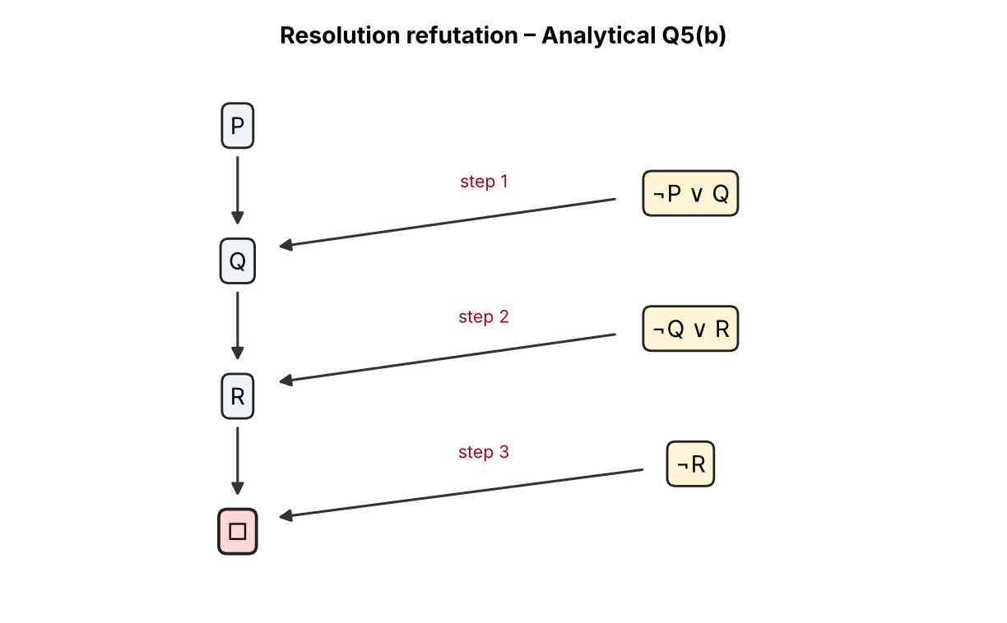
The empty clause is derived, so the formula is unsatisfiable. This agrees with the truth table.
(c) What the result reveals about the KB { P→Q, Q→R, P, ¬R }
- The KB is inconsistent: it has no model, so it cannot describe any possible world.
- The first three sentences entail R (P ⇒ Q ⇒ R by Modus Ponens), but the fourth says ¬R, so a direct contradiction exists.
- Principle of explosion: from an inconsistent KB every sentence can be derived, so a reasoning system would answer “true” to anything and can no longer be trusted.
- Implication for a logical agent: it must run consistency checks (a failed satisfiability test or derivation of □). It should then locate the conflicting sentences and repair them by belief revision or a truth-maintenance system, rather than continue to reason.
- This is also the basis of refutation: KB ⊨ α exactly when KB ∪ { ¬α } is inconsistent.
Summary of results
Question | Final result
Q1 | Match is cancelled when it rains; CNFs: (¬R∨W)∧(¬W∨C); ¬A∨¬D; (P∨G)∧(¬P∨¬G)
Q2 | C proved; □ derived in 3 resolution steps
Q3 | FOL sentences written; MGU θ = { x/A, y/g(z) }
Q4 | Migratory(Eagle) proved by both methods; forward chaining 3 firings vs backward chaining 6 goal checks
Q5 | Formula unsatisfiable; KB inconsistent

SIMATS ENGINEERING
ASSESSMENT TOOL 1
COURSE NAME: Artificial Intelligence COURSE CODE: CSA17
COURSE OUTCOME COVERED
CO3: Analyze knowledge representation and reasoning using propositional logic, FOL, inference, resolution, chaining methods, knowledge representation to perform logical reasoning for drawing valid conclusions and decision making. (BL4)
Assessment Tool Weightage: 50% Duration: 1 Hour
Questions: 4 Total Marks: 40
Annexure A
CASE STUDY
Code of Conduct:
I R. Deekshitha (192412194) certify that this submission is my original work and that I have adhered to the guidelines specified for this assessment.
I understand that any violation of academic integrity rules will result in disciplinary action.
Signature of the student: R. Deekshitha
Case Study 1 – Smart Medical Diagnosis System
Understanding of the case and key issues
- A rule-based logical agent diagnoses a patient from symptoms; diagnoses are only “possible”, not confirmed.
- Patient A has Fever, Cough and Breathlessness. Rash is not reported, which matters for the Measles rule.
- Rules overlap (Cough appears in two rules), so more than one diagnosis can be derived at once.
(a) Propositional representation
Symbol | Meaning
F | Patient has Fever
C | Patient has Cough
R | Patient has Rash
B | Patient has Breathlessness
FLU | Possible Flu
MEA | Possible Measles
PNE | Possible Pneumonia

Knowledge | Propositional form | CNF clause
Rule I | F ∧ C → FLU | ¬F ∨ ¬C ∨ FLU
Rule II | F ∧ R → MEA | ¬F ∨ ¬R ∨ MEA
Rule III | C ∧ B → PNE | ¬C ∨ ¬B ∨ PNE
Facts (Patient A) | F = T, C = T, B = T | F ; C ; B
R (Rash) is not in the facts. Under the closed-world assumption it is treated as false; in an open-world reading it is unknown. Either way, Rule II cannot fire.
(b) Forward chaining
Step | Rule examined | Premises available? | Fact derived
0 | Initial facts | – | F, C, B
1 | Rule I: F ∧ C → FLU | F ✓, C ✓ | FLU (Possible Flu)
2 | Rule II: F ∧ R → MEA | F ✓, R ✗ (no rash reported) | Not fired
3 | Rule III: C ∧ B → PNE | C ✓, B ✓ | PNE (Possible Pneumonia)
4 | Re-check all rules | No new fact | Fixed point

Diagnoses for Patient A: Possible Flu and Possible Pneumonia. Possible Measles is not derived.
(c) Backward chaining: Goal = Pneumonia
Level | Goal | Reduction | Outcome
0 | PNE | Rule III is the only rule with head PNE; sub-goals C AND B | Expand
1 | C | Known fact | ✓
1 | B | Known fact | ✓

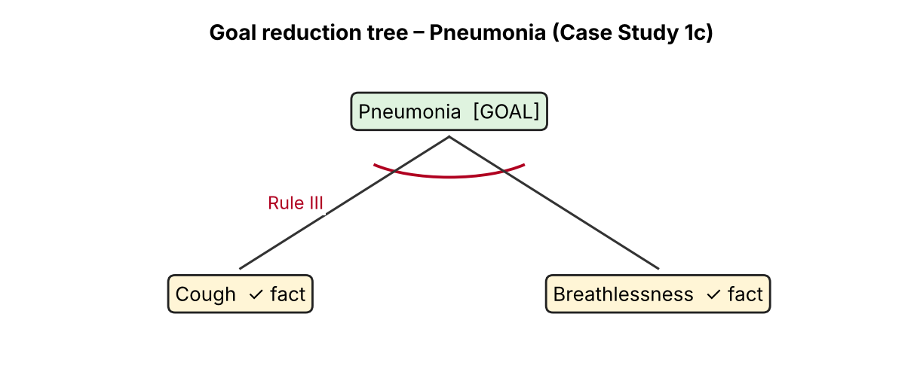
Both sub-goals are facts, so ‘Patient A has Pneumonia’ is confirmed as a possible diagnosis (2 fact look-ups + 1 rule).
Solution design and recommendation
- Because Flu and Pneumonia are both derived, the agent should rank by severity (add Rule: PNE → UrgentReferral) and not report Flu alone.
- Add negative evidence (e.g., ¬Rash) and a certainty factor per rule, as symptom rules are probabilistic.
- Every output must end with “refer to a doctor”; the agent is a screening aid, not a final diagnosis.
Case Study 2 – Autonomous Traffic Management Agent
Understanding of the case and key issues
A FOL knowledge base routes emergency vehicles. Rule 1 marks an emergency vehicle's path clear, Rule 2 gives it a green signal, and Rule 3 lets vehicles behind it proceed. Abbreviations: V = Vehicle, E = EmergencyType, CP = ClearPath, G = GreenSignal, Red = RedSignal, Bh = Behind, Pr = Proceed.
(a) Unification of Rule 1 with the facts
Rule 1: ∀x V(x) ∧ E(x) → CP(x). Variables are bound by unifying each premise with a fact.
Step | Unify | Result (θ) | Remark
1 | V(x) with V(Ambulance) | θ1 = { x/Ambulance } | First candidate fact
2 | E(x)θ1 = E(Ambulance) with fact E(Ambulance) | θ = { x/Ambulance } | Identical, so no new binding
3 | Conclusion CP(x)θ | CP(Ambulance) | New fact
alt. | V(x) with V(CarA) → θ = { x/CarA } | E(CarA) has no matching fact | Fails, so backtrack to step 1
Substitution set (MGU): θ = { x/Ambulance }. Rule 2 then fires with the same θ to give G(Ambulance) ∧ ¬Red(Ambulance).
For Rule 3: V(x) with V(CarA) gives { x/CarA }; Bh(CarA, y) with Bh(CarA, Ambulance) gives { y/Ambulance }; G(Ambulance) is already derived. Hence θ = { x/CarA, y/Ambulance }.
(b) Resolution proof of Proceed(CarA)
Clauses in CNF (variables standardised apart; Rule 2's consequent is split by distributing ∨ over ∧: ¬CP ∨ (G ∧ ¬Red) ≡ (¬CP ∨ G) ∧ (¬CP ∨ ¬Red)):
No. | Clause | Origin
C1 | ¬V(x) ∨ ¬E(x) ∨ CP(x) | Rule 1
C2 | ¬CP(x) ∨ G(x) | Rule 2 (part a)
C3 | ¬CP(x) ∨ ¬Red(x) | Rule 2 (part b)
C4 | ¬V(x) ∨ ¬Bh(x,y) ∨ ¬G(y) ∨ Pr(x) | Rule 3
C5 | V(Ambulance) | Fact
C6 | E(Ambulance) | Fact
C7 | V(CarA) | Fact
C8 | Bh(CarA, Ambulance) | Fact
C9 | ¬Pr(CarA) | Negated goal

Step | Clauses resolved | θ | Resolvent
1 | C9 and C4 | { x/CarA } | ¬V(CarA) ∨ ¬Bh(CarA,y) ∨ ¬G(y)
2 | step 1 and C7 | – | ¬Bh(CarA,y) ∨ ¬G(y)
3 | step 2 and C8 | { y/Ambulance } | ¬G(Ambulance)
4 | step 3 and C2 | { x/Ambulance } | ¬CP(Ambulance)
5 | step 4 and C1 | { x/Ambulance } | ¬V(Ambulance) ∨ ¬E(Ambulance)
6 | step 5 and C5 | – | ¬E(Ambulance)
7 | step 6 and C6 | – | □ (empty clause)

The empty clause is derived in 7 steps, so Proceed(CarA) is proved. C3 (¬Red) was not needed. Each step uses the substitution shown, consistent with part (a).
(c) Is the KB sufficient for two simultaneous emergency vehicles?
No. Rule 1 gives every emergency vehicle its own ClearPath and green signal independently, so conflicting commands are possible. Suppose two ambulances A1 and A2 approach the same junction from crossing roads:
- Rules 1 and 2 give G(A1) ∧ ¬Red(A1) and G(A2) ∧ ¬Red(A2).
- Any physical-safety axiom such as “crossing roads cannot both be green” (G(A1) → Red(A2)) then contradicts ¬Red(A2).
- The KB becomes inconsistent, so by explosion it can derive anything, including unsafe commands.
Missing knowledge:
Addition | Formal content | Justification
Location and road facts | Approach(x, road), Crossing(road1, road2), Junction(j) | Conflicts exist only between crossing roads
Mutual exclusion | ∀r1,r2: Crossing(r1,r2) ∧ Green(r1,t) → Red(r2,t) | Prevents two crossing green signals
Priority | Priority(Ambulance,2), Priority(FireTruck,2), Priority(Police,1); HigherPriority(x,y) | Gives a rule to choose the winner
Tie-breaker | EarlierArrival(x,y) → HigherPriority(x,y) when priorities are equal | Makes the choice total, so no deadlock
Guarded Rule 1 | V(x) ∧ E(x) ∧ ¬Blocked(x) → CP(x), where Blocked(x) ← ∃y (E(y) ∧ Crossing(road(x),road(y)) ∧ HigherPriority(y,x)) | Only the winning vehicle gets ClearPath
Time argument | Green(x,t), Red(x,t) instead of Green(x) | Signals change over time, so static facts become stale
Justification: with the guarded Rule 1 and the mutual-exclusion axiom, at most one of two crossing emergency vehicles receives ClearPath, so the KB stays consistent. The other vehicle gets its turn when the first has passed. Rule 3 should also be restricted so that “Proceed” still checks that nothing else is blocking the junction.
Case Study 3 – Agricultural Expert Reasoning System
Understanding of the case and key issues
The KB links soil condition to irrigation, drip application and crop risk. Symbols: S = SoilDry, I = IrrigationNeeded, W = CropWheat, D = ApplyDripMethod, K = CropAtRisk. The key issue is what is still provable when a fact (SoilDry) is missing.
(a) Conversion to CNF
Sentence | Original | Eliminate → | Move ¬ inward | CNF clause
P1 | S → I | ¬S ∨ I | no change | ¬S ∨ I
P2 | (I ∧ W) → D | ¬(I ∧ W) ∨ D | ¬I ∨ ¬W ∨ D | ¬I ∨ ¬W ∨ D
P3 | (¬D ∧ W) → K | ¬(¬D ∧ W) ∨ K | (D ∨ ¬W) ∨ K | D ∨ ¬W ∨ K
Fact 1 | S | – | – | S
Fact 2 | W | – | – | W
Distribution of ∨ over ∧ is not needed: each sentence became a single clause.
(b) Resolution refutation of ApplyDripMethod (D)
Negated goal: ¬D. Clause set: (1) ¬S∨I, (2) ¬I∨¬W∨D, (3) D∨¬W∨K, (4) S, (5) W, (6) ¬D.
Step | Clauses resolved | Resolved on | Resolvent
1 | (6) ¬D and (2) ¬I ∨ ¬W ∨ D | D | (7) ¬I ∨ ¬W
2 | (7) and (1) ¬S ∨ I | I | (8) ¬S ∨ ¬W
3 | (8) and (4) S | S | (9) ¬W
4 | (9) and (5) W | W | (10) □

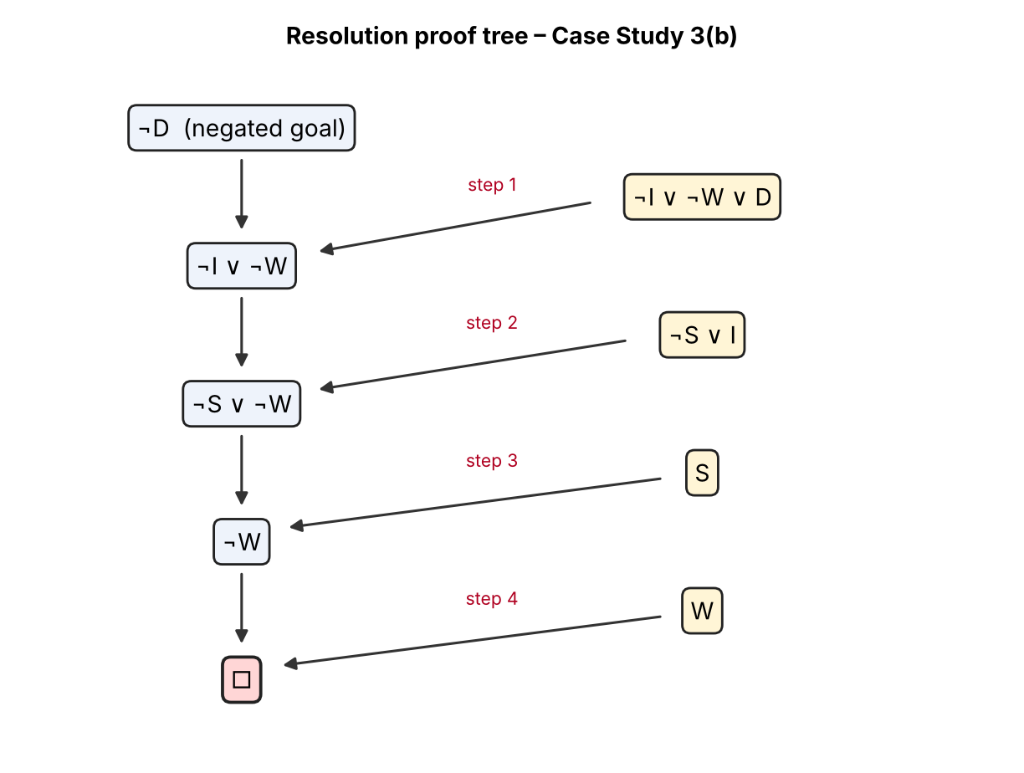
The empty clause is derived, so ApplyDripMethod is proved. Clause (3) was not needed.
(c) Effect of removing the fact SoilDry
Step | Reasoning | Outcome
1 | Known: W only. P1 (S → I) needs S, so Modus Ponens cannot fire. | I is not derivable
2 | P2 needs I and W; I is missing. | D is not derivable
3 | P3 needs ¬D ∧ W; ¬D is not known either (Modus Tollens needs ¬D or ¬K). | K is not derivable
4 | Check by models: there are 7 models of the remaining KB; D is true in 6 and false in 1; K is true in 4 and false in 3. | Neither D, ¬D nor K is entailed
5 | Resolution check: add ¬K and try to reach □. The clause set stays satisfiable, e.g. W=T, D=T, S=I=K=F. | K cannot be refuted, so it does not follow

Answer: ‘CropAtRisk’ does NOT follow. In classical (monotonic) logic, removing a fact only removes conclusions. Even with SoilDry present, K does not follow, because D becomes true and makes P3 vacuous.
Reasoning patterns used: Modus Ponens (blocked), Modus Tollens, resolution refutation and model checking. Default reasoning: if the system adopts the closed-world assumption (“D not provable ⇒ ¬D”), K would be concluded as a default warning. This is non-monotonic: restoring SoilDry makes D provable and withdraws the warning.
Solution design and recommendation
- Treat a missing SoilDry as unknown, not false; the agent should request a soil-moisture sensor reading before advising.
- Show CropAtRisk only as a labelled default (“possible risk, data incomplete”) and keep it retractable.
Case Study 4 – Wumpus World Knowledge Agent
Understanding of the case and key issues
The agent moves on a 4×4 grid. A cell is written [column, row] and the agent starts at [1,1]. Percepts: Stench[1,2], Breeze[1,1], Glitter[2,2]. Adjacent cells share a side, so: adjacent([1,2]) = {[1,1], [1,3], [2,2]} and adjacent([1,1]) = {[1,2], [2,1]}.
Assumptions (standard Wumpus semantics): (A1) a percept is sensed in the cell where it is listed, so the agent has stood in [1,1], [1,2] and [2,2] and is alive; (A2) a percept not listed for a visited cell is absent there; (A3) there is one Wumpus, and pits and the Wumpus are not in the start cell.
(a) Belief state and Modus Ponens
Step | Premises | Inference (Modus Ponens) | Derived knowledge
1 | Stench[1,2]; Stench[1,2] → Wumpus adjacent to [1,2] | MP | W[1,1] ∨ W[1,3] ∨ W[2,2]
2 | Breeze[1,1]; Breeze[1,1] → Pit adjacent to [1,1] | MP | P[1,2] ∨ P[2,1]
3 | Glitter[2,2]; Glitter[x,y] → Gold at [x,y] | MP, {x/2, y/2} | Gold at [2,2]
4 | Agent alive in [1,1], [1,2], [2,2] (A1, A3) | no hazard in a visited cell | ¬W ∧ ¬P at each of these cells
5 | ¬W[x,y] ∧ ¬P[x,y] → Safe[x,y] | MP, three bindings | Safe[1,1], Safe[1,2], Safe[2,2]

Belief state: cells [1,1], [1,2], [2,2] safe; Gold at [2,2]; the Wumpus is in one of {[1,1], [1,3], [2,2]}; a Pit is in one of {[1,2], [2,1]}. The knowledge in rows 4 and 5 narrows these in part (b).
(b) Forward chaining to locate the Wumpus and the Pit
Step | Fact used | Elimination | Remaining possibilities
1 | Stench[1,2] (rule 1) | – | Wumpus ∈ { [1,1], [1,3], [2,2] }
2 | Breeze[1,1] (rule 2) | – | Pit ∈ { [1,2], [2,1] }
3 | Safe[1,1] (start cell) | remove [1,1] | Wumpus ∈ { [1,3], [2,2] }
4 | Safe[2,2] (agent stands there, Glitter) | remove [2,2] | Wumpus = [1,3]
5 | Safe[1,2] (agent stands there, Stench) | remove [1,2] | Pit = [2,1]
6 | Cross-check: no Stench at [1,1] and none at [2,2]; no Breeze at [1,2] and none at [2,2] | consistent with W[1,3], P[2,1] | Confirmed

Result: Wumpus at [1,3] and Pit at [2,1]. Without the visited-cell facts (rows 3 to 5), the possibilities would remain W ∈ {[1,3], [2,2]} and P ∈ {[1,2], [2,1]}.
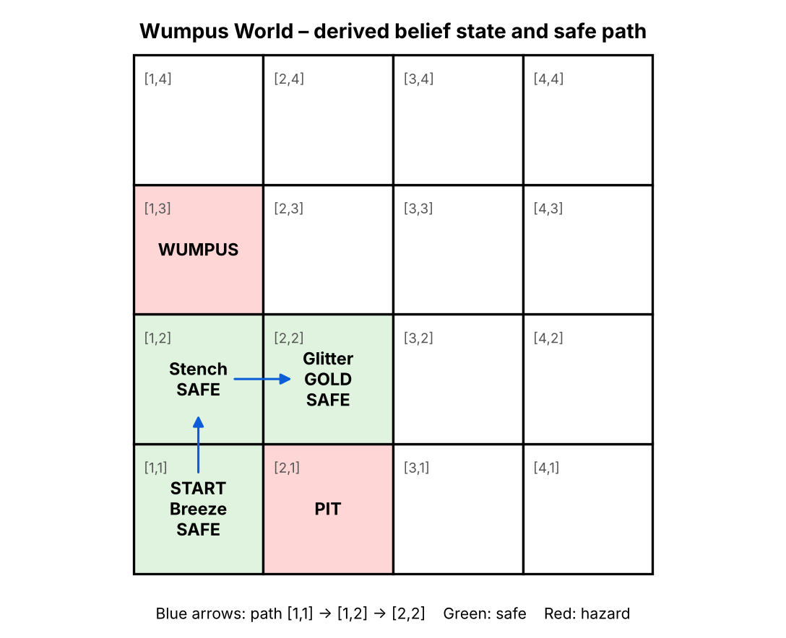
(c) Is the path [1,1] → [1,2] → [2,2] safe?
Cell | Hazard check | Verdict
[1,1] | Start cell; Wumpus and Pit cannot be here (A3) | Safe
[1,2] | Pit ≠ [1,2] (Pit is at [2,1]); Wumpus ≠ [1,2] (it is at [1,3]); agent alive there | Safe
[2,2] | Wumpus ≠ [2,2] (it is at [1,3]); no Pit; Gold present | Safe

Conclusion: the path is safe. The hazards lie at [1,3] and [2,1], which are adjacent to the path but are not on it. The agent can collect the gold at [2,2] and return along the same cells. It must not step to [1,3] or [2,1].
Residual risk: this holds under assumptions A1 to A3. If the agent had only the percepts and had not yet entered [1,2] or [2,2], the path would not be provably safe (the Pit could be in [1,2], the Wumpus in [2,2]), and a cautious agent should gather more evidence first.
Solution design and recommendation
- Keep a visited-and-alive fact for every cell the agent enters and derive Safe from it, in addition to rule 4.
- Store absent percepts explicitly (¬Stench, ¬Breeze), since they are what rule out neighbouring cells.
- Plan: grab the gold at [2,2], then retrace [2,2] → [1,2] → [1,1] and exit; the Wumpus need not be shot.

SIMATS ENGINEERING
ASSESSMENT TOOL 2
COURSE NAME: Artificial Intelligence COURSE CODE: CSA17
COURSE OUTCOME COVERED
CO3: Analyze knowledge representation and reasoning using propositional logic, FOL, inference, resolution, chaining methods, knowledge representation to perform logical reasoning for drawing valid conclusions and decision making. (BL4)
Assessment Tool Weightage: 50% Duration: 30 Minutes
Questions: 30 Total Marks: 30
Annexure A
MCQ
Code of Conduct:
I R. Deekshitha (192412194) certify that this submission is my original work and that I have adhered to the guidelines specified for this assessment.
I understand that any violation of academic integrity rules will result in disciplinary action.
Signature of the student: R. Deekshitha
Answer Key (Quick View)
Q1 | Q2 | Q3 | Q4 | Q5 | Q6 | Q7 | Q8 | Q9 | Q10
b | b | b | b | b | c | b | b | d | b

Q11 | Q12 | Q13 | Q14 | Q15 | Q16 | Q17 | Q18 | Q19 | Q20
b | b | c | b | b | b | b | c | c | c

Q21 | Q22 | Q23 | Q24 | Q25 | Q26 | Q27 | Q28 | Q29 | Q30
c | c | c | c | c | c | c | c | c | c

Detailed Answers with Justification
Q.No | Answer | Reason
1 | b) An agent that uses a knowledge base and logical inference to decide actions | A logical agent keeps a KB and infers what to do; random, scripted and reward-driven agents are not logical agents.
2 | b) ¬P ∨ Q | P → Q ≡ ¬P ∨ Q. Its contrapositive ¬Q → ¬P is also equivalent, but option (c) says “only”, so option (d) fails.
3 | b) A conjunction of disjunctions (clauses) | CNF = AND of OR-clauses, e.g. (A ∨ B) ∧ (¬C ∨ D).
4 | b) Every entity that is a student passes | ∀x means “for all x”, so it is a universal statement.
5 | b) Make two logical expressions syntactically identical | A substitution θ is found so that both expressions become the same.
6 | c) A contradiction: the original goal is proven | □ means KB ∧ ¬Goal is unsatisfiable, so the goal follows from the KB.
7 | b) Data-driven / bottom-up | It starts from known facts and fires rules to derive new facts.
8 | b) The goal and works backward to verify supporting facts | It starts from the query and reduces it to sub-goals.
9 | d) Distribute AND over OR | CNF needs OR distributed over AND. Distributing AND over OR gives DNF. Skolemization is part of FOL-to-CNF.
10 | b) Defining domain concepts, relations and axioms formally in FOL | It is the process of building a KB for a domain.
11 | b) Q must be true | From P → Q and P, infer Q.
12 | b) Makes two terms identical with minimal variable binding | It is the most general substitution, so any other unifier is an instance of it.
13 | c) Backward Chaining | Goal-directed reasoning avoids deriving irrelevant facts.
14 | b) Cannot represent objects, relations or quantifiers | Propositional logic has only atomic true/false propositions.
15 | b) Adding ¬G to the KB and deriving a contradiction (empty clause) | Proof by contradiction: KB ∪ {¬G} unsatisfiable ⇒ KB ⊨ G.
16 | b) Improving performance by examining examples or experience | The agent learns from data or experience rather than being programmed rule by rule.
17 | b) Generalizing a hypothesis from specific training examples | Induction goes from specific to general (deduction goes general to specific).
18 | c) A test on an attribute / feature | Internal nodes test attributes, branches are values, leaves hold class labels.
19 | c) Uses prior domain knowledge to explain and generalize a single example | EBL needs a domain theory and can learn from one example.
20 | c) All features are conditionally independent given the class label | This “naive” assumption makes P(x|class) a simple product.
21 | c) Directly computing maximum likelihood estimates from observed data | With no hidden variables, parameters are counted frequencies.
22 | c) The dataset contains hidden (latent) variables | EM alternates the E-step (expected values) and the M-step (maximize parameters).
23 | c) Introduce non-linearity to enable learning of complex patterns | Without it, stacked layers collapse into one linear map.
24 | c) The error is propagated backward from output to input layers to adjust weights | Gradients are computed with the chain rule from the output layer back.
25 | c) Finding the maximum-margin hyperplane that separates classes | SVM maximizes the margin to the nearest points (support vectors).
26 | c) Operating in a high-dimensional feature space without explicitly computing coordinates | Kernels compute inner products directly in the feature space.
27 | c) Cumulative reward received over time through interaction with the environment | The RL objective is the maximum expected return.
28 | c) A model-free, off-policy temporal difference learning method | It learns Q-values without a model and updates with the best next action.
29 | c) The model fits training data too closely and generalizes poorly to new data | Low training error but high test error.
30 | c) RL learns via trial-and-error with reward feedback; SL learns from labeled examples | RL has no labelled answers, only reward signals.

Notes on the two trickiest questions
- Q2: the equivalences of P → Q are ¬P ∨ Q and the contrapositive ¬Q → ¬P. Option (c) is worded “¬Q → ¬P only”, which wrongly claims it is the only equivalent form, so the safe and standard answer is (b).
- Q9: converting to CNF uses: eliminate ↔ and →, move ¬ inward, (Skolemize in FOL), then distribute ∨ over ∧. “Distribute AND over OR” is the DNF direction, so it is not a CNF step: (d).
Quick Revision Tables
Logic and reasoning (Q1 to Q15)
Topic | Key point
Equivalences | P → Q ≡ ¬P ∨ Q ≡ ¬Q → ¬P; P ↔ Q ≡ (P → Q) ∧ (Q → P); ¬(A ∧ B) ≡ ¬A ∨ ¬B
CNF recipe | Remove ↔ and → ⇒ move ¬ inward ⇒ (Skolemize) ⇒ distribute ∨ over ∧ ⇒ write clauses
Resolution | Add ¬Goal; resolve complementary literals; □ ⇒ Goal proved (sound and complete)
Forward vs backward | Forward: data-driven, bottom-up, derives all consequences. Backward: goal-driven, top-down, only relevant sub-goals
Unification | Find θ making expressions identical; MGU is the most general such θ; occurs check prevents x/f(x)
Propositional vs FOL | FOL adds objects, predicates, functions and quantifiers (∀, ∃)

Learning (Q16 to Q30)
Concept | Key point
Inductive vs EBL | Induction needs many examples and generalizes; EBL uses domain theory to generalize from one
Decision tree | Internal node = attribute test; branch = value; leaf = class
Naive Bayes | Assumes features are conditionally independent given the class
Complete data vs EM | Complete data: count frequencies (ML). Hidden variables: EM (E-step, M-step)
Neural network | Activation adds non-linearity; backpropagation sends the error backward to update weights
SVM and kernel | Maximum-margin hyperplane; the kernel trick works in high dimension without explicit coordinates
Reinforcement learning | Maximize cumulative reward by trial and error; Q-learning is model-free, off-policy TD
Overfitting | Fits training noise, poor generalization; reduce with more data, regularization, validation

SIMATS ENGINEERING
ASSESSMENT TOOL 3
COURSE NAME: Artificial Intelligence COURSE CODE: CSA17
COURSE OUTCOME COVERED
CO3: Analyze knowledge representation and reasoning using propositional logic, FOL, inference, resolution, chaining methods, knowledge representation to perform logical reasoning for drawing valid conclusions and decision making. (BL4)
Assessment Tool Weightage: 20% Duration: 1 Hour
Questions: 5 Total Marks: 30
Annexure A
Resolution Algorithm Implementation
Code of Conduct:
I R. Deekshitha (192412194) certify that this submission is my original work and that I have adhered to the guidelines specified for this assessment.
I understand that any violation of academic integrity rules will result in disciplinary action.
Signature of the student: R. Deekshitha
Resolution Algorithm: Method Used in All Questions
Resolution is a refutation-complete inference rule for clauses. From two clauses containing complementary literals, it produces their resolvent:
{ α ∨ ℓ } and { β ∨ ¬ℓ } ⟹ { α ∨ β }
Algorithm (PL-Resolution)
- Convert KB to clauses (CNF): remove →, then each rule P → Q becomes ¬P ∨ Q.
- Negate the goal and add it to the clause set.
- Pick two clauses with a complementary pair, resolve them, and add the resolvent (if new).
- If the empty clause □ appears, the goal is proved. If no new clause can be added, the goal is not entailed.
Why it works: □ shows KB ∧ ¬Goal is unsatisfiable, so every model of the KB satisfies the Goal (KB ⊨ Goal). The method is sound and complete for propositional logic.
Notation: each resolution step is written “(i, j) → resolvent”, where i and j are clause numbers.
Question 1 – Rain and Wet Ground
Problem understanding
Two facts: a rule (rain ⇒ wet ground) and an observation (it is raining). Goal: prove the ground is wet.
1. Propositional logic
Symbol | Meaning | Sentence
R | It is raining | S1: R → W
W | The ground is wet | S2: R

2. Conversion to CNF
No. | Sentence | CNF clause
1 | R → W ≡ ¬R ∨ W | ¬R ∨ W
2 | R | R

3. Negate the goal
Goal W, so clause 3: ¬W.
4. Resolution steps
Step | Clauses | Resolvent
1 | (1) ¬R ∨ W and (3) ¬W [on W] | (4) ¬R
2 | (4) ¬R and (2) R [on R] | (5) □

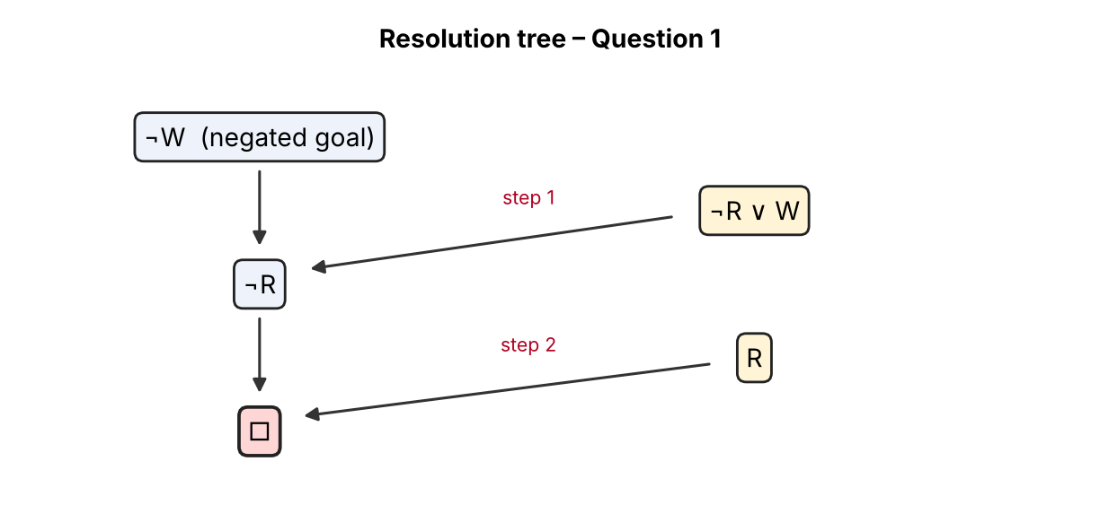
5. Conclusion
The empty clause □ is obtained, so the negated goal contradicts the KB. The ground is wet: the goal is proved.
Question 2 – Student Assignment Submission
Problem understanding
A rule links submission to internal marks, and Rahul submitted. Goal: Rahul receives internal marks.
1. Propositional logic expressions
Symbol | Meaning | Sentence
S | Rahul submitted the assignment | S1: S → M
M | Rahul receives internal marks | S2: S

2. CNF of the premises
No. | Sentence | CNF clause
1 | S → M ≡ ¬S ∨ M | ¬S ∨ M
2 | S | S

3. Negated goal
Clause 3: ¬M.
4. Resolution
Step | Clauses | Resolvent
1 | (1) ¬S ∨ M and (3) ¬M [on M] | (4) ¬S
2 | (4) ¬S and (2) S [on S] | (5) □

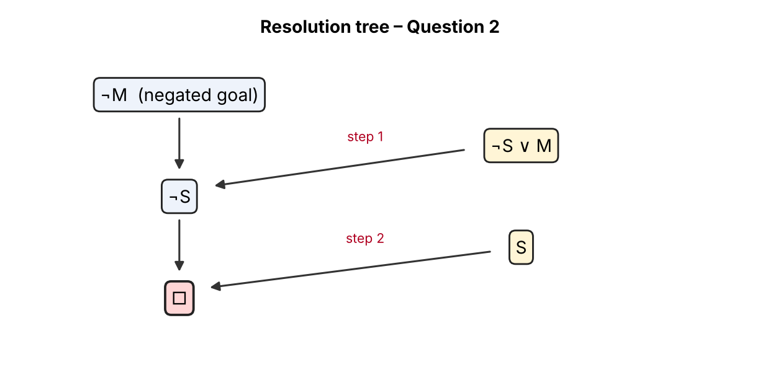
5. Conclusion
□ is derived, so the goal is proved: Rahul receives internal marks.
Extra (FOL view): the general rule is ∀x Submits(x) → Marks(x). Unifying with Submits(Rahul) uses θ = { x/Rahul }, which gives the same proof for any student.
Question 3 – Library Membership
Problem understanding
Library members can borrow books, and Priya is a member. Goal: Priya can borrow books. Here resolution is run until no new clause can be generated, so the full saturation is shown.
1. Propositional logic
Symbol | Meaning | Sentence
L | Priya is a library member | S1: L → B
B | Priya can borrow books | S2: L

2. CNF
No. | Sentence | CNF clause
1 | L → B ≡ ¬L ∨ B | ¬L ∨ B
2 | L | L
3 | Negated goal ¬B | ¬B

3. Resolution until saturation
Round | Pair resolved | Resolvent | New?
1 | (1) and (2) on L | B | Yes, clause 4
1 | (1) and (3) on B | ¬L | Yes, clause 5
1 | (2) and (3) | none (no complementary literals) | –
2 | (4) B and (3) ¬B | □ | Contradiction
2 | (5) ¬L and (2) L | □ | Contradiction

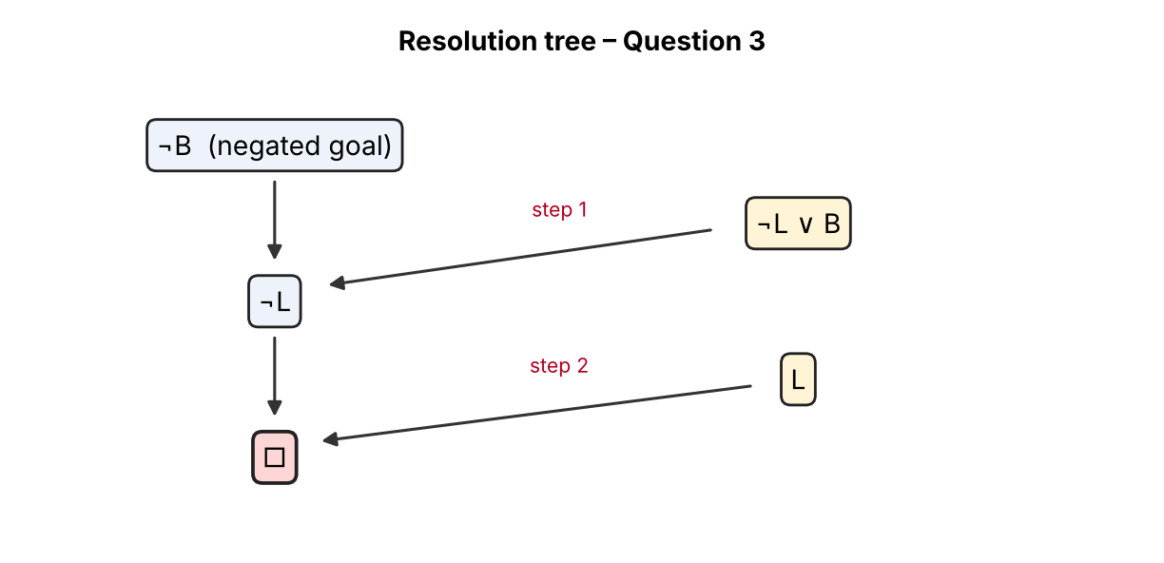
Check without the negated goal: resolving only clauses (1) and (2) gives B and then no further new clause. The set { ¬L∨B, L, B } is saturated with no □, so the KB itself is consistent. The contradiction is caused only by ¬B.
4. Final conclusion
□ is derived (by two independent routes), so Priya can borrow books: the goal is proved.
Question 4 – Placement Eligibility
Problem understanding
Clearing the aptitude test makes a student eligible, and Arun cleared it. Goal: Arun is eligible for placement.
1. Propositional logic
Symbol | Meaning | Sentence
C | Arun cleared the aptitude test | S1: C → E
E | Arun is eligible for placement | S2: C

2. CNF clauses
No. | Clause | Origin
1 | ¬C ∨ E | C → E ≡ ¬C ∨ E
2 | C | Fact

3. Negate the goal
Clause 3: ¬E.
4. Resolution step by step
Step | Clauses | Resolved on | Resolvent
1 | (1) ¬C ∨ E and (3) ¬E | E | (4) ¬C
2 | (4) ¬C and (2) C | C | (5) □

5. Resolution tree
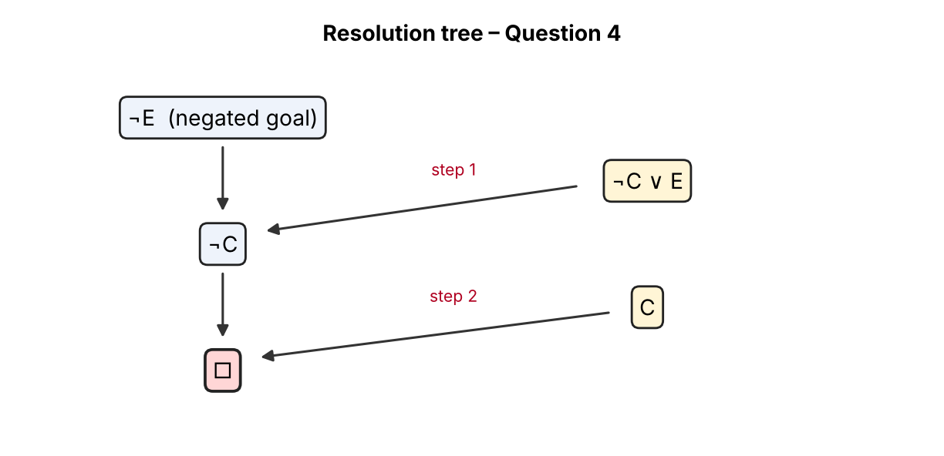
Yellow boxes are input clauses, blue boxes are derived resolvents, and the red box is the empty clause.
Conclusion: □ is reached in two steps, so Arun is eligible for placement: the goal is proved.
Question 5 – Access Control System
Problem understanding
A two-rule chain: correct password ⇒ authenticated ⇒ access granted. The user entered the correct password. Goal: access is granted.
1. Propositional logic
Symbol | Meaning | Sentence
P | User enters the correct password | S1: P → A
A | User is authenticated | S2: A → G
G | User is granted access | S3: P

2. Implications to CNF
No. | Sentence | CNF clause
1 | P → A ≡ ¬P ∨ A | ¬P ∨ A
2 | A → G ≡ ¬A ∨ G | ¬A ∨ G
3 | P | P

3. Negated goal
Clause 4: ¬G.
4. Resolution to derive □, with explanation of each step
Step | Clauses resolved | Resolvent | Explanation
1 | (2) ¬A ∨ G and (4) ¬G | (5) ¬A | G and ¬G cancel: if access is not granted, authentication must have failed
2 | (1) ¬P ∨ A and (5) ¬A | (6) ¬P | A and ¬A cancel: if not authenticated, the password was not correct
3 | (6) ¬P and (3) P | (7) □ | P and ¬P cancel: this contradicts the fact that the password was correct

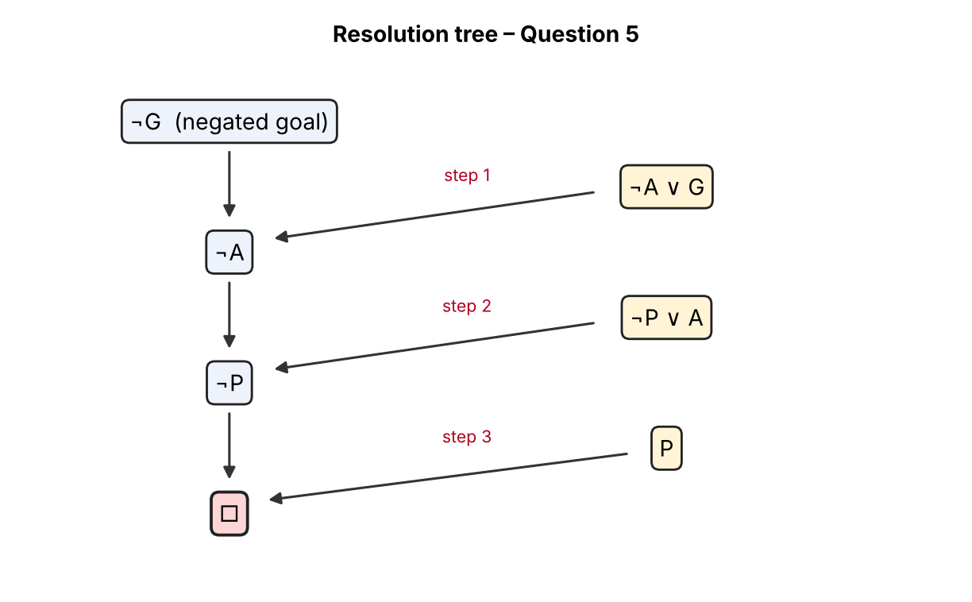
5. Final conclusion
The empty clause is derived, so the user is granted access: the goal is proved. The proof walks the chain backward (G → A → P), mirroring two Modus Ponens steps.
Summary of All Five Proofs
Q | Knowledge base (CNF) | Negated goal | Steps to □ | Result
1 | ¬R∨W ; R | ¬W | 2 | Ground is wet ✓
2 | ¬S∨M ; S | ¬M | 2 | Rahul gets marks ✓
3 | ¬L∨B ; L | ¬B | 2 | Priya can borrow ✓
4 | ¬C∨E ; C | ¬E | 2 | Arun eligible ✓
5 | ¬P∨A ; ¬A∨G ; P | ¬G | 3 | Access granted ✓
Observation: a chain with n implications needs n + 1 resolution steps. Q1 to Q4 have one implication (2 steps) and Q5 has two (3 steps).

